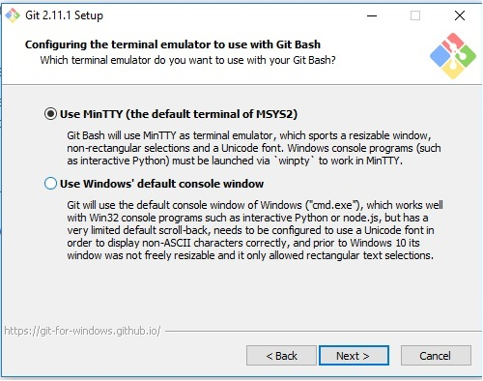
SSH Connection
- Access to the website https://developers.openshift.com/getting-started/windows.html#client-tools and follow the instructions word by word.

- Install the following programs:
- Ruby with Ruby Installer.
- Git control version.
- rhc Ruby gem.
- This link will show us how to intall and configure PUTTY on Windows to access Openshift via SSH -----https://www.youtube.com/watch?v=dZwngyEtWmU (the file SSH-2-RSA id_rsa.ppk must be generated at the end).

- Import the porject to Eclipse from the previously cloned folder on the system and afterwards update through Synchronize from GIT Project to Web Project.
- To update the current project through cmd console, use the next commands:
- To access Web project folder, type cd <project name>
- Git add .
- Git Commit –m “update message”
- Git push
If everything worked, a message will display listing the modified files and confirming that everything is OK.
6. Verify the web page to make sure the changes are correct.

